

LAN Center and Repair Shop

April 2014

Andrew Reid, Roger Myers, Michael Fesser, and Logan Noonan

Table of Contents

Executive Summary 3

Missions Statement 4

Goals and Objectives: 4

SWOT Analysis 4

Marketing Plan 5

Competition 6

Strategy 8

Sales Forecast 12

Operational Plan 15

Appendices 20

# Executive Summary

The Zone is a computer repair shop and LAN center founded as a partnership in Charlottetown, PE. The owners, Andrew Reid, Roger Myers, Michael Fesser, and Logan Noonan, all are passionate gamers who love to see others interact while enjoying their favorite games. Our tech manager, Roger Myers, has years of experience managing tech repair services at various organizations. The Zone aims to offer quality repairs to its clientele, as well as a safe environment for players of all ages to enjoy games with their friends and family.

The following are the main points covered in this business plan:

* The objective of The Zone is to become a profitable repair shop and LAN center in the City of Charlottetown
* The mission of The Zone is to provide a safe environment to game in, and quality repair services
* The marketing strategy and operational plan of The Zone
* The goods and services offered by the zone are computer repairs and builds, tech tutorials, gaming rental services, and gaming memorabilia

The purpose of this business plan is to allow transparent insight for any who are interested in our business outline. The investment from the four owners will be $15,000 each, giving a starting budget of $60,000. The calculated start-up cost for this business is $55,615 allowing this business to be founded without a bank loan. Based on our financial assessment, this business would begin to become profitable within its fourth year.

# Missions Statement

The Zone is designed to be a place of fun, friendship, and learning. We are here to offer a safe environment for gamers of all ages to enjoy their favorite games with their friends and families. On top of our LAN center, the Zone’s tech shop aims to provide quality repair services and tutorials to the citizens of Charlottetown.

# Goals and Objectives:

The zone aims to become a leading tech service provider in the City of Charlottetown. We also want to offer a fun environment to gamers and a facility for gaming tournaments.

* Host a LAN tournament
* Have a birthday booking in our first month
* Make a reasonable profit while doing something we enjoy
* Become the first choice for computer service needs

# SWOT Analysis

|  |  |
| --- | --- |
| Strengths | Weaknesses |
| * Only LAN center on PEI * Little competition for repairs * Deals mostly with disposable income * Expert Owners * Prime location * Unique * Place for kids to hang out after school | * Kids can have own their machine * Games popularity becomes mobile based * Backfire from health community |
| Opportunities | Threats |
| * Fun field of work * Tournaments for expert gamers * Parties for all ages * Business Synergy Seminars | * Future Shop can have competitive edge on pricing on repairs * Internet fees can increase monthly * Health community/Parenting groups pressure to be more active |

# Marketing Plan

#### Economic Overview

It’s no secret that video gamers are one of the most lucrative consumer markets, if they can be appealed too.  According to a report conducted by the Entertainment Software Association in 2013, a whopping 58% of Americans play video games, and there are an average of two gamers in each game-playing household throughout the United States. According to Michael D. Gallagher, president and CEO of the ESA, “No other sector has experienced the same explosive growth as the computer and video game industry”.  The amount of money generated by the video games industry (including magazines, add-on content, etc.) has more than doubled since 2002 and in 2012 the industry raked in ~20.77 billion dollars in sales.

In PEI, there are currently no business of this type. There was a business known as AdrenaLAN Gaming that reportedly was successful and profitable, but the owner decided to move onto something else. On the east coast, there has been an increase in the popularity of social and competitive gaming. PEI has a group of dedicated fighting game players who try to meet up and play together on a regular basis, and members of the group have expressed interest in having a location to host their game nights and/or tournaments. Also, there exists groups in Nova Scotia and Halifax who already hold large-scale tournaments, and could be interested in using our building to host such events.

#### Customers

The ESA separates game players by age into three fairly equal demographics: under 18 years, 18-35 years, and 36+ years. The latter is the largest, accounting for 36% of the player base while the other two come in at 32% each. While we at The Zone would certainly welcome players above the age of 36 into our store, our marketing would be better off targeted more so at younger clients. Older clients would be more likely to stay at home to play games, as a large driving force behind The Zone is socializing with other gamers. The presence of younger clients could dissuade members of the 36+ group from attending on a regular basis; however they could still be drawn in by special events. Primarily, the business will be promoted as a place for teens and young adults to hang out after their out of school for the day and want to play video games with like-minded people.

In summation, our business is open to anyone; however our key demographic profile is hard-core gamers (male or female) under the age of 30.

Due to the fact that our business operates both as a game room and as a site for tutorials and repairs, our business also has to be marketed towards less-experienced users as well. This is not an IT consulting firm, meaning we are not interested in business as clients, or in fixing PoS systems, databases, or other programs that would not be used by a home PC user.  Users below 30 tend to be more comfortable with technology and more willing to attempt their own solutions.  With this in mind, our key demographic for repairs and tutorials is home PC users, generally between the ages of 30 and 70 and preferably within a local area. This market is expected to grow as time goes on as demand for computers increases among retirees and other less-experienced users.

# Competition

As far as LAN centers go, The Zone will completely dominate the market on Prince Edward Island, as long as no new competitors arise. The Zone is, however, far from being the only computer repair shop in the area. Future Shop is a large corporation that occupies a huge share of the market, while Combat Computers is another, much smaller competitor.

**Future Shop:**

191 Buchanan Dr, Charlottetown, PE C1E 2E4

(902) 626-2081

**Combat Computers:**

92 Capital Dr, Charlottetown, PE C1E 1E7

(902) 892-7283

#### Competitive Analysis

|  |  |  |  |  |  |  |
| --- | --- | --- | --- | --- | --- | --- |
| FACTOR | The Zone | Strength | Weakness | Future Shop | Combat Computers | Importance to Customer |
| Price | Our prices are competitive, but we still need to make a profit. | - | - | It will be hard to directly compete with a company this size. | They will have no advantage over us. | 4 |
| Quality | Our repairs are high quality and tested. | X | - | Seriously though what was the quality like? | They are at an industry standard level. | 4 |
| Service | Good customer service is one of the cornerstones of our business. | X | - | They are not known for fantastic service. | They are not known for fantastic service. | 5 |
| Expertise | Repairs are performed only by certified professionals. | X | - | Industry standard of A+ certification. | Industry standard of A+ certification. | 4 |
| Company Reputation | As a new company, we will have to build up our reputation. | - | X | Good prices, above average service. | Average prices, average service. | 5 |
| Location | Our location is ideal for a LAN center and good for anything else. | X | - | Farther from downtown in a large shopping mall. | Not a location you would happen to drive by and notice. | 3 |
| Sales Method | Repairs are paid for when the client comes to pick up the repaired device. | - | X | Commission sales, up selling other products. | Repairs are paid for when the client comes to pick up the repaired device. | 3 |
| Credit Policies | Non-existent | - | X | Future Shop Card, based on current credit score | None | 2 |
| Advertising | Some print, mostly word of mouth | - | X | T.V., Radio, and Newspaper. | Some T.V. and Radio ads. | 2 |
| Image | Gamers will want to bring their computers to us as we promote an image of being gamers. | X | - | Come here give us your money, it’s cheap. | Similar to us but far less friendly. | 4 |

#### Niche

The Zone is already unique in that there is no other business on PEI that offers a gaming-oriented LAN center. As a small business, our efforts will be focused on good quality service and products and building a good reputation as a computer repair shop. In order to distinguish ourselves from other businesses offering repairs, we will be cordial, friendly, and understanding of customer’s issues to try to ensure that the client will remember us next time they need help. The fact that our workers are certified and repairs and conducted in-house means we can speak from a place of understanding and help the customer to understand the issue. Overall, we will do whatever we can to satisfy the customer and to build a strong relationship with our clients.

# Strategy

Promotion

Our pre-opening marketing campaign would have to start at least a month before opening day. This gives us enough time to generate buzz for our business, and makes sure that we don’t get to opening day only to realize we have no customers.

The bulk of our marketing will be done using social marketing. This method of marketing is great because it is virtually free of cost. Representatives of our company will go out to schools, city events and bars wearing The Zone branded t-shirts, handing out flyers that list our rates and giving away free memberships. This will all be done with the goal of convincing as many people as possible that our business will be an awesome place to spend their time, or at least to come check it out. Word of mouth and personal interaction will be key in getting the word out about The Zone.

A website will be designed that is aesthetically appealing and that focuses the reader to our list of offered products and services. A good website is key as it is probably how the majority of our potential clients can examine and become familiar with our goods & services.

Another main method of promotion for The Zone will be in signage and posters that will be posted everywhere; on telephone poles, notice boards around town, and ensuring that we always have posters that can be seen at all major schools in the area. These posters will have a link to our website where potential customers can learn all about what it is we offer. The business will be promoted as a nice place where like-minded individuals can meet and hang out. For the parents, we will promote the fact that our business is safe and supervised and that our employees are trained to handle emergency situations, should they arise.

While avenues for advertising such as local TV and radio ads could generate additional business, the cost seems to outweigh the potential advantages. The type of demographic we are trying to reach is unlikely to hear about the business through a local radio or TV station, and it’s likely that the social marketing described above would be much more effective, and also much more inexpensive.

Print advertising should be used, as it is relatively inexpensive for the amount of time your ad is visible, especially when compared to some web advertising and the traditional forms of TV and radio. Local magazines such as The Buzz can ensure that our ad is seen by a lot of people for a relatively low price.

Promotional Budget

Promotion for The Zone should be relatively inexpensive; our marketing will be focused on social outings, give-a-ways and social media marketing. As we the owners are capable with regards to social marketing and social media marketing, these could be achieved virtually free of cost. Our main marketing costs will come paying for our advertising space in The Buzz, doing give-a-ways such as The Zone branded t-shirts, and posters.  We plan on also partnering up with EB Games and Future Shop that if they bring in receipt for a new game that we are promoting they can either gain entry into a tournament or maybe a few hours of gameplay.

**Before start up:**

Print Advertising $890.00 (1 full, inside page; runs from Sep - Jun)

Give-A-Ways $350.00 (t-shirts, gaming mice/keyboards, vouchers)

Flyers/Posters $150.00 (500 flyers)

________

Total Marketing Budget $1390.00

**Ongoing:**

Print Advertising $890.00 (1 full, inside page; runs from Sep - Jun)

Give-A-Ways $150.00 (t-shirts, gaming mice/keyboards, vouchers)

Flyers/Posters $100.00 (ongoing promotion & to promote special events)

________

Total Marketing Budget $1150.00

Pricing

Overall, our pricing scheme is not absolutely essential to our business’s marketing. Since our company has no competitors on the LAN center side, our hourly rate for playing PC games or consoles does not have to be competitive.Services such as repairs are classified and priced by the Tech Manager based on the severity of the issues that need repairing. Computer repairs are conducted in-house so prices on repairs will be very competitive with other businesses such as Future Shop and Staples. Most costs can be waived, if necessary, in the interest of customer satisfaction. The customer must cover the cost of the parts and materials, and tech manager will then decide a price based on the difficulty of the repair and the number of hours spent doing so. Computer building and software tutorials will be offered at flat rates. Builds will be thoroughly tested and assembled to specifications. Tutorials will be extremely comprehensive and in-depth (if the client so chooses).

For the LAN center side, customers will pay an hourly rate for time spent on our PCs or consoles. Overall, game-time is priced in a way that encourages repeat business. There are two pricing schemes: members and non-members. Non-members pay an hourly rate of $5.00 (taxes in) for PC gaming, and every third hour is free. This should ensure that most customers are spending at least $10 before leaving the store. Members pay a marginally cheaper rate of $3.00 (taxes in) per hour, again with every third hour being free of charge. While memberships would be recommended to all customers, the membership will only start to pay for itself after a total of nine sessions of two hours or longer. This is mainly for dedicated customers, or for younger clients who need somewhere to hang out after school (i.e. coming in on a daily basis).

Also on the LAN center side, we will allow for customers to book the entire center. This would be of interest for competitive gaming groups looking to stage tournaments and/or live events. We believe that these organizations would be willing to $250.00 to rent out a cool, gaming-related location that already has a lot of the infrastructure in place. Additionally, our business would stand to make a lot more money from the sale of drinks and other consumables.

A large part of our profits are expected to be generated through the sale of drinks and snacks. Through our Pepsi distribution line, we will sell fountain pop. Fountain pop will be offered in three sizes, small, medium or large, each priced at $2.00, $2.50 and $3.00 respectively with the large size coming with free refills. The convenience of having refreshment only a few steps away should ensure that our customers are purchasing their food and beverage products from us. Also offered will be energy drinks for $4, small bags of chips for $1.50, $2.00 candy bars and a selection of 5¢ candies. Other that gaming on PC we also have select tables available for people to play Magic the Gathering and role-playing games free of charge in hopes that they may purchase pop or good while staying.

The last type of product that we offer is gaming-related apparel and memorabilia. Split Reason is a maker of gaming-related apparel that showcases unique and attractive designs that would appeal to our key demographic. These shirts would be priced based on their cost at wholesale. While these are not necessarily included to be a big seller and generator of profits, the presence of this type of merchandise could lend credibility to our business.

Distribution

All products and services will be purchased and paid for on-site, similar to a standard retail set-up.

Proposed Location

Based on our target demographic, our location needs to be in a fairly populated and busy area. Also very important is that it be within walking distance of at least 1 public junior high or high school, and also easily reachable using public transit. The location we have selected, a 1500 sq. ft. store in the strip mall located at 300 University Avenue in Charlottetown, adequately meets and exceeds these requirements. It is conveniently located within walking distance of Colonel Gray High School, and easily reachable by any of the busses which go up and down University Avenue every 15 minutes. The location is also fairly close to Charlottetown Rural High School and post-secondary institutions like UPEI and Holland College, all large sources of potential customers.  It is also located near transit.

The location has two external entrances one in the front and one in the back.   The back entrance will allow for easy deliveries while the external front entrance allows for access outside of normal business hours.  The Zone being located in a commercial space will not have unique zoning requirements or building code requirements.  Also we have budgeted for renovations of the space to make it suit our needs.  These will be limited to pulling up walls and if necessary adding/modifying the plumbing to add bathrooms.  We have budgeted 20,000 for these renovations.

Upon entering the space, the first thing you see is a staircase that leads to another door. This entry way allows us to be able to have a nice buffer area between the outside world and The Zone’s internal atmosphere. With a name like The Zone, we want our business to have a unique feel and environment. This will be achieved by dimming the lighting, selecting suitable furniture, mood lights, and also low-volume background music. With any luck, customers will be attracted to The Zone’s ambiance and they will want to come back.

# Sales Forecast

#### Start-Up Cost

We plan on not having to borrow any money from the bank. With our $60,000 investment ($15,000 each), we will be able to cover all of the start-up cost.

|  |  |
| --- | --- |
| Start-Up Costs | Cost ($) |
| Accountant fees | $600 |
| Rent | $1500 |
| Internet & Phone Installation | $95 |
| Consumables and Merchandise | $3650 |
| Renovation | $20,000 |
| Computers and Hardware | $24,000 |
| Marketing & Advertising | $1390 |
| Permits | $300 |
| Furniture | $3500 |
| Software | $580 |
| Total start-up costs | $55,615 |

#### Loss Expectancy

We expect to lose money within the first year because of start-up cost. We expect to make-up $13,751.98 each year and within three years cover the start-up cost and become profitable.

|  |  |
| --- | --- |
| Profit & Loss Forecast 2012 | 2015 |
| Total Sales | $125,688 |
| Total Expenses | $167,551.02 |
| Gross Profit | -$41,863.02 |

#### Typical Month Expenses

Here is the breakdown of a typical month’s expenses. Wages are going be the largest expense followed by our rent/lease. We choose two only use a two man operation because we felt this will save us the most cash in the long run. Our wages are based off the Tech manager receiving $16.00/hr and the sales associate $11.00/hr. Our internet bill we search BellAliant for a high speed plan and doubled it so that we could have two lines in case one was faulty. To calculate the taxes we took our profit and charged a 14% tax rate.

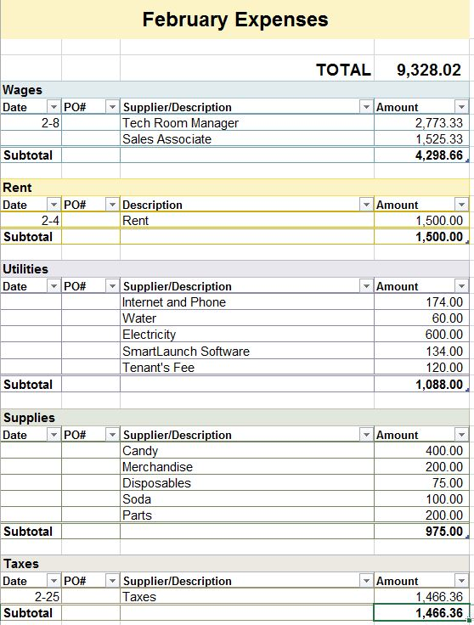

#### Typical Month Income

Here is a potential outlook for our profits in a given month. Our strategy of using multiple ways to gather income is why this business is so strong. Our tech room can produce a great cash flow as well as the gaming portion. Our assumptions for income on the repair portion is based off a third of the business that Future Shop produced. Our assumptions for the LAN center are based off our computers being used 47% of the time. This is industry standards for LAN centers. We base our pop and candy sales off one in five people purchasing a drink every hour for the LAN center being open. With these assumptions we predict that we will be profitable in the long run.

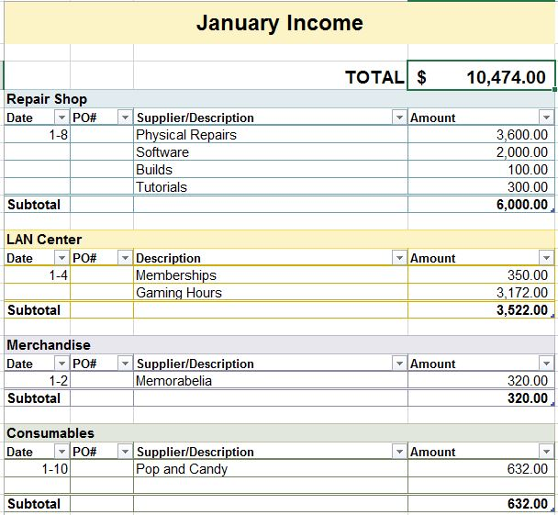

#### Start-up Year Expenses

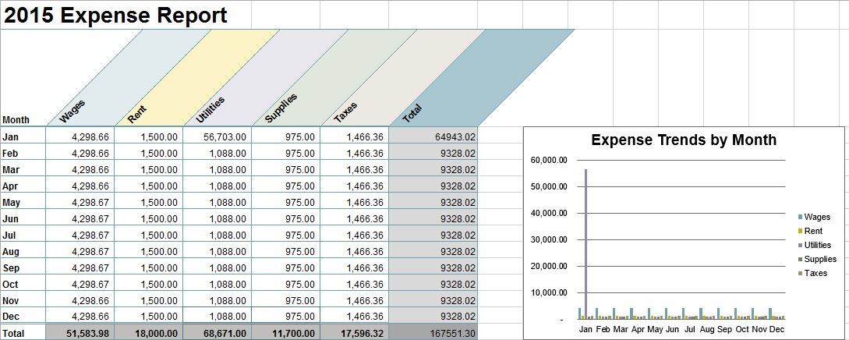

# Operational Plan

#### Legal Environment

The Zone will require a number of permits, forms, a standard Fidelity bond, but it will require no licences.

Required Permits and Forms:

* Building permit
* Occupancy permit
* Signage permit
* 911 Cost Recovery permit
* Employers Registration form
* Canada Customs Coding form
* Canada Customs Invoice
* Federal Business Registration
* Sound Licences
* Health and Safety for Small Business permit

All the permits should cost approximately 300 dollars, but we are budgeting for 1000 dollars for any unexpected and unknown permit costs.  The Zone will be full compliance with OSHA and will register with the workers compensation board of Canada.

The Zone will require two main insurance policies.  The first is a general liability insurance policy which will protect us from any damages to customer’s equipment that might occur.  The second policy will be a general waiver form that will have to be signed by customers who are using the LAN center if they are over 18 or by their guardians if they are under 18.  This will protect us from any liability should the unforeseen happen.

Trademarks, copyrights, or patents (pending, existing, or purchased)

We plan on teaming up with an online company called SmartLaunch.  They have software that tracks user time and also has partnership with game developers to license software to internet cafes.  SmartLaunch will allow us to manage people usage and give us vital statistics on computer usage.  This can give us an edge in which merchandise to purchase based on which game is being played the most.

#### Day to day

The Zone has two core services, the LAN center and the Tech Shop.

The Zone’s Business hours will be: Wednesday-Thursday 3pm-10pm, Friday 3pm-12am Saturday 1pm-10pm, Sunday 11am-6pm

#### Tech Shop

The tech room will run during regular business hours of Monday-Friday 9am-6pm. The later hours will allow for people to pick up repairs after their work hours.  Most repair shops see the most drop off repairs on Monday when their equipment breaks over the weekend and come into Charlottetown on Monday morning.

#### LAN Center

The LAN centre will be covered in the evening by another staff member once the tech room manager leaves for the day. This member will also be opening and closing the store on Saturday and Sunday.  The Tech shop will be closed during this time but available for drop offs and picks just no repair work will be done.

#### Computer Repair and Optimization

This will involve fixing minor software problems, minor hardware install, Windows and Mac restores, motherboard replacements, screen replacements, transferring computer data, and getting rid of unwanted programs.  The price for these services will be a rate of $50/hr with the minimum charge being based on a half hour of work.

#### Computer Build

This will involve putting the physical computer components together as well as designing the system.  Assembly will be a flat rate or $100 and there will be no per hour charge regardless of the length of time assembly takes.  Design will be a value added service.   Along with these services will also offer a “build on a budget” service.  With this service we will design a budget system and assemble it at a reduced cost.

#### Computer Tutorial

The final service we offer are basic computer tutorials.  Examples of this service would include setting up email, Skype, MS Office use, and teaching the customer about new technology.  The fee would be $50/hr for this service.

#### Personnel

The Zone will have four equal owners but only one The Tech manager will run the day to day operations. The other personnel will be a student that will be able to work late and work for minimum wage. This will allow us to keep our cost down. In case of an emergency all owners should be equipped with the ability to run the day to day operations.

#### LAN Center Duties

* Clean and maintain the bathrooms
* Clean and maintain the LAN center
* Run the counter and the cash register
* Deal with any minor issues that might arise
* Pass any major issues over to a manager
* Assist Managers when running tournaments

#### Tech Room Duties

* Clean and maintain the equipment (LAN Center)
* Clean and maintain the tech room
* Be able to perform all tech services
* Deal with any minor issues that might arise
* Pass any major issues over to a manager
* Assist Managers when running tournaments

In addition to the duties there are some basic requirements for team members.  All tech room team members must be A+ certified.  Also all team members must be WHMIS certified and at least one team member who is working must have a valid first aid certificate.  Finally all communications between team members will be by phone, email, or Skype.

#### Inventory

The vast bulk of the inventory we at The Zone will keep is stock for the counter sales.  This include all the candy and soft drinks as well and any souvenirs.  We will also keep a small number of computer parts for the LAN center.

The cost for the candy varies greatly but total counter inventory would not exceed $500 at any given time.  About two thirds of this cost would come from candy bars.  The rest would be from the other varieties of candy. A box of thirty-six candy bar costs $30.

The cost of the inventory of pop would be about the same as for the candy.  Most syrups from wholesales cost $5 a liter and purchasing directly from Pepsi should reduce this cost.  If we keep twenty liters of each flavour, a total of four flavours would be a net cost of $500.  An additional cost would be the cost for the CO2.  A fifty pound tank costs $50 dollars in CO2 to fill.  Finally a small selection of power drinks would not exceed $50.

The computer parts required for quick turnaround repairs in the LAN center would be $2000 dollars.  All parts for tech center computer repairs/upgrades would be ordered as needed.

The cost of the shirts would be about $100.  We have not yet decided what additional gamer gear we would carry but feel there would be no need to carry more than $500 worth at a time. The total value of the inventory at any given time would be $3650.  The time for most supplies to arrive would be from two to five days.  The shirts could take one to two weeks.

#### Suppliers

The supplies would be NCIX and NewEgg for computer parts, Pepsi for all drinks, various wholesales for the candy and we have not decided the supplier for the t-shirts.  For most of the supplies there should be no delivery issues as most have warehouses in Ontario or Halifax.  The only issue is production time on the t-shirts but they will not be a major selling point.

All the companies chosen are well established and have excellent track records for service.  The costs of all supplies will fluctuate up and down over the course of doing business, with the exception of Pepsi, we have the ability to easily change suppliers.  Any fluctuating costs should not be a major issue.

**NCIX**

Ontario Head Office

2-3900 14th Avenue.

Markham, ON L3R 4R3

Canada

Toll Free: 1-877-624-9308

Telephone: 905-752-9888

Fax: 905-475-9715

**NewEgg**

9997 Rose Hills Road

Whittier, CA 90601

USA

Toll Free: 1-800-390-1119

Fax: (626) 271-9403

**Pepsi Co**

14 Hunter Street East

Peterborough ON K9J 7B2

Canada

Toll Free: 1-800-433-2652

**Royal Candy Company**

717 Fellowship Road Unit C

Mount Laurel, New Jersey 08054

USA

Toll Free: (888) 261-8277

sales@royalcandycompany.com

support@royalcandycompany.com

# Appendices

Screen shots from our social media.

Facebook. 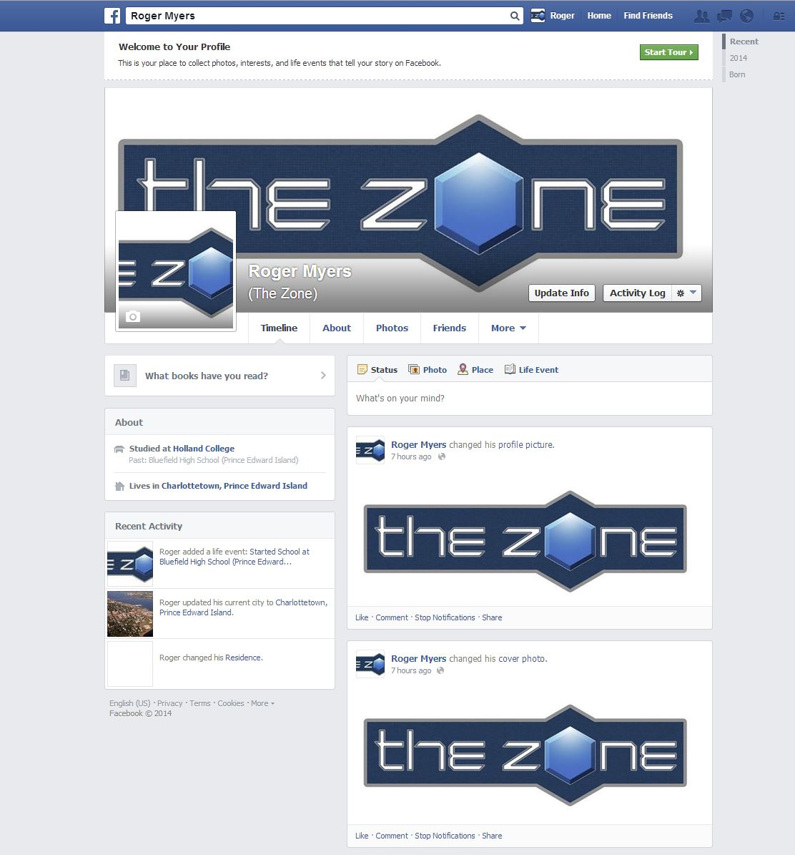

#### Twitter.

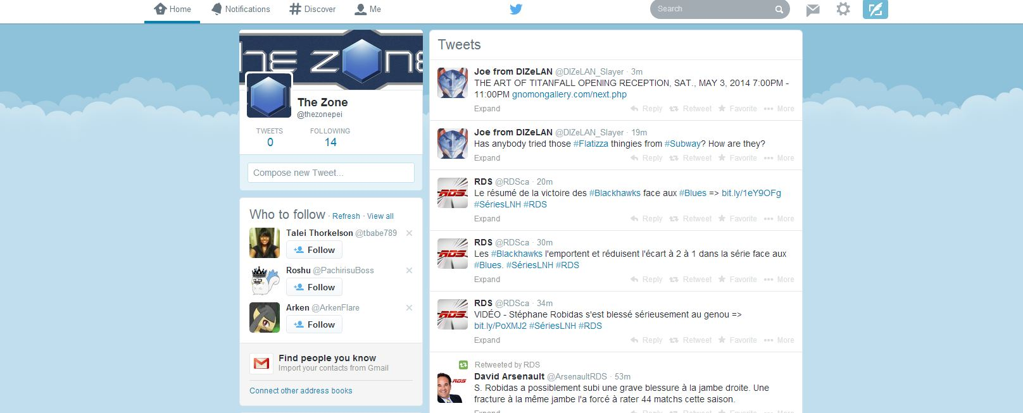

#### Mockup T-Shirt

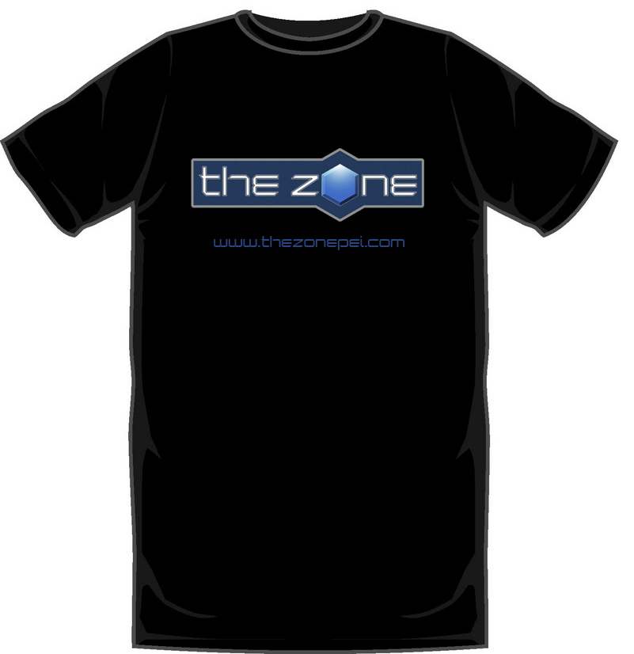

#### Resumes

**Logan Noonan**

56 Bonavista Drive **•**  Cornwall, PE **•**  C0A 1H0 • *P:* **1-902-213-5717 •**  *E:* **noonanlt@gmail.com**

**SKILLS**

* Knowledge and aptitude with HTML, CSS, Java, JavaScript, PHP, and SQL programming languages
* Artistically inclined with studio arts and graphic design experience
* Technical and practical knowledge of computer security, Linux servers, and database design
* Fluently bilingual (French)

**EDUCATION**

*HOLLAND COLLEGE (CLASS OF 2015)*

* Currently taking Computer Information Systems program
* Focused on software programming, operating systems and network security
* Will receive Computer Analyst/Programmer diploma upon graduation

*BLUEFIELD HIGH SCHOOL (CLASS OF 2010)*

* Graduated with honors for recognition of excelling in courses
* Awarded bilingual certificate upon graduation

**EXPERIENCE**

*ROBIN’S DONUTS (DEC. 2011 – PRESENT)*

**BAKER**

* Produced goods for 12 Robin’s locations on PE as well as fulfilling additional catering orders
* Contacted stores to find out how much product was on hand, adjusted orders based on need using Microsoft Excel

*ON-LINE SUPPORT (APR. – SEPT. 2011)*

**TECHNICAL SUPPORT ASSISTANT**

* Assisting customers with issues related to their Apple devices
* Used empathy and tone to diffuse difficult situations
* Employed problem solving skills on a regular basis to find solutions to customer issues

**REFERENCES ARE AVAILABLE UPON REQUEST**

**Michael Fesser**

251 Keppoch Road, Stratford, PE. C1B 2J5 (902)367-1911 mail.michaelfesser.ca

**Education**

Computer Information Systems, 2013 – Current

Holland College, Charlottetown, PE

PC Support Specialist, 2007-2010 (specific courses completed – no diploma)

Academy of Learning, Saskatoon, SK; Dartmouth, NS

Network & Internet Support Specialist Diploma with Honors, 2003

CDI College of Business and Technology, Saskatoon, SK

High school Diploma, 1995

Holy Cross High school, Saskatoon, SK

**Skills & Abilities**

Programming and scripting languages

* Java, JavaScript, php, SQL, C#, HTML, CSS

Database integration and technical skills

* MySQL, Apache Server, Linux Server, A+ certification, Networking and Security Essentials, MS Office

Interpersonal skills

* Through years working in the service industry, gained very strong customer service skills
* Through strong time management skills, maintained a 90% course average while working 13-15 hours a week
* Have been given a leadership role in the produce department as well as increased responsibilities to help take some of the pressure off of management

**Experience**

Colleague Produce Department

Atlantic Superstore, Charlottetown, PE

September 2011 – Current

* Supervisory duties, paperwork

Service Clerk, Produce Department

The Real Canadian Superstore, Saskatoon, SK

May 1999 – Jan 2006

* Supervisory duties, ordering stock and paperwork

Andrew D. Reid   
2 Crestwood Dr.   
Charlottetown PE C1A 3H3

Telephone: 894-5369

Cell: 314-4730   
  
E-mail: andrew.dave.reid@gmail.com

**EDUCATION**



|  |  |  |
| --- | --- | --- |
| Charlottetown, PE | Holland College | September 2013 – May 2015 |

* Currently working towards a diploma in Computer Information Systems
* Wed development training in HTML, CSS, Javascript, and PHP
* Object oriented language training in Java and C#
* Training in both Linux desktop and Linux server

|  |  |  |
| --- | --- | --- |
| Charlottetown, PE | University of Prince Edward Island | September 2009 – April 2012 |

* Two years studying sciences with a focus in chemistry
* A year of studying arts with a focus in religious studies

**WORK HISTORY**



|  |  |  |
| --- | --- | --- |
| **Lifeguard Supervisor** | **City of Charlottetown** | **Summer 2013** |

* Promoted to Lifeguard Supervisor in Summer 2013; supervised 11 Lifeguards
* Managed scheduling, in-service training, and task assignment of the lifeguards
* Oversaw transfer of daily pool income

|  |  |  |
| --- | --- | --- |
| **Product Expert** | **Future Shop** | **September 2011 – May 2013** |

* Provided expert level support for a variety of different products and services
* Assisted customers with technical support for their mobile electronics
* Demonstrated the ability to work in a fast paced and sometimes stressful environment

|  |  |  |
| --- | --- | --- |
| **Waiter** | **Elmwood Heritage Inn** | **Summer 2010 – Summer 2013** |

* Served food and beverages in a high end establishment
* Cleared food an dishes to maintain an inviting dining environment

|  |  |  |
| --- | --- | --- |
| **Lifeguard** | **City of Charlottetown** | **Summer 2008 – Summer 2012** |

* Oversaw the health and water safety of up to 130 individuals at one time
* Maintained biannual certifications in both National Lifeguard Service and First aid and CPR for 6 years

|  |  |  |
| --- | --- | --- |
| **Front Desk Representative** | **UPEI Sports Centre** | **September 2010 – August 2011** |

* Operated cash register, managed float, and reconciled cash
* Provided quality customer service to facility users



HIGHLIGHTS OF VOLUNTEER EXPERIENCE



* Volunteered building houses in Grand Goave, Haiti, May 2013
* Volunteered for three weeks with a prison outreach program in Bolivia, May 2012
* Volunteered at the QEH as a front desk representative from June 2009-May of 2011
* Volunteered teaching English in the Czech Republic from May 12-25, 2010

REFERENCES



* Christopher Drummond, Parks and Recreation Charlottetown, Phone: (902) 388-0875
* Carol MacDonald, Elmwood Bed and Breakfast, (902) 368-3310
* Phil Woodworth, Pastor, Cornerstone Baptist Church, Phone: (902) 940-3773

Enter any content that you want to repeat, including other content controls. You can also insert this control around table rows in order to repeat parts of a table.

#### Helpful Links

A few links.  The Chamber of Commerce has some fairly useful info.

Some advertising stuff

[Advertising | Banner Ads Prince Edward Island | PEI Online Banner ad](http://www.advertisingcanada.net/pe/)

[BUZZon.com - Advertising - Prince Edward Island (PEI)](http://www.buzzon.com/advertising)

[myguide - Affordable Television Advertising - Eastlink Advertising](http://www.eastlink.ca/AdvertisingServices/myguide.aspx)

[Charlottetown Chamber of Commerce - Member Benefits](http://www.charlottetownchamber.com/membership-2/member-benefits/)

[Prince Edward Island Banner](http://www.advertisingcanada.net/pe/)

Business space for rent

[Lease, Buy, or Rent Commercial & Office Space in Prince Edward Island | Real Estate | Kijiji Classifieds](http://www.kijiji.ca/b-commercial-office-space/prince-edward-island/c40l1700118) [Downtown | Lease, Buy, or Rent Commercial & Office Space in Prince Edward Island | Kijiji Classifieds](http://www.kijiji.ca/b-commercial-office-space/prince-edward-island/downtown/k0c40l9011)

[Charlottetown Chamber of Commerce - Office Space in Greater Charlottetown Area](http://www.charlottetownchamber.com/business-development/office-space-in-greater-charlottetown-area/) [Charlottetown Chamber of Commerce - Membership Dues](http://www.charlottetownchamber.com/membership-2/membership-rates/)

[Downtown Charlottetown Inc. - OfficeSpaceInventory Business](http://www.downtowncharlottetown.com/business/office-space-inventory)

Just a thought on a basic machine.  Likely over the top.

[NCIX.com - Canada's Premier Computer Store - Online PC Discount Store, Buy Computer Accessories](http://pc.ncix.com/pcbuilder/index.php?action=getprice&id=4344546&platformid=1000)

Utilities (will need to be adjusted for PEI rates and specific locations

<http://www.mge.com/saving-energy/business/use-analysis/>